# Research

## Does it exist?

Seeing as the technologies required for this project all exist already (energy harvesting, short range radio, haptic feedback) I began research by seeing if similar products already exist on the market and if so, do they meet the objectives I have set out for the device? in short no, many devices exist that fulfill one or more of the objective but they fail to meet all in a reasonable manor.

I will outline some of these devices below –

Hey Bracelet

(House of Haptics, 2018) – ‘The revolutionary bracelet that sends touch over distance’

The Hey Bracelet consists of a pair of bracelets and a smartphone companion app. These items align with my first idea closely with their tag line of ‘The revolutionary bracelet that sends touch over distance' they seem to be aimed squarely at lovers with distance separating them. The bracelet consists of a motor that allows the band to tighten around the wearer’s wrist and a touch sensor on the outside to instigate this action in another user. However, these devices diverge from my idea in two key areas. Firstly cost, at $114.99 at the time of writing (18/11/18) it is difficult to consider these a low-cost item, and secondly power, they require charging via USB.

### Sony Wena

(SONY EUROPE LIMITED, 2018)- ‘The watch. Reborn.’

The Sony Wena is not a watch but in fact a strap that should fit many watch faces and is available in multiple sizes and designs, including several Sony made face designs. This device is positioned as a more all-round smart device with GPS (GPS, GLONASS, QZSS and SBAS compatible), Bluetooth 4.2 low energy, heartbeat and accelerations sensors, OLED display and NFC like (‘Wena pay’) hardware. Its features include receiving notifications from a smart phone, contactless payment and fitness tracking as well as being water resistant to enable to user to wear the device in the shower or humid conditions. The device has an expected battery life of approximately 1 week with a charging time of 1.5 hours. So, in many ways this device would cover the functions of my idea with two key differences, firstly it requires charging (albeit far less frequently than other described devices) and secondly its price tag. Starting at £349 the device is clearly aimed at the premium end of the market and can certainly not be considered disposable or suitable for a younger user.

### Generic low-cost smartwatch

There are many such devices on the market as of 2019 and it would be beyond the scope of this work to review all of them, so in this instance I will focus on a single model the ‘V8 Smartwatch’ this device is made by several companies and often sold under the label’s ‘GONOKER’ , ‘Leegoal’ and ‘DreaT’.

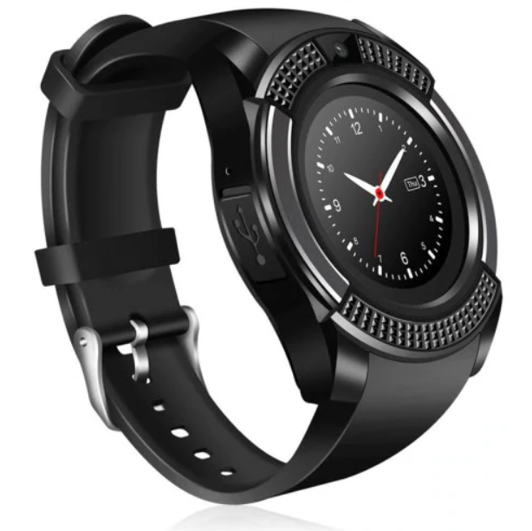

This device consists of the basic functionality of a feature phone in the form factor of a watch. It includes a MediaTek 6261s processor which is based around an ARM Cortex M4 or M7, this is assumed based on information from MediaTek’s website and a datasheet stating it uses the ARM7-E instruction set (Huang, 2012; MediaTek Inc, 2019) . This variant of the chip uses the J-S extensions to enable acceleration of Java based applications. It contains an inbuilt logic for Bluetooth 3.0, GSM/GPRS/EDGE, FM radio, AAC audio (with amplifier), I2C, SPI, UART, USB and SDIO and can be debugged using a JTAG interface. These are accompanied by 128MB or RAM, a 1.51” 240x240 display and a 0.3MP camera. This high amount of integration enables the device to run for a day or more on a single 280mAh battery.

The device can be set to take notifications from an accompanying Bluetooth enabled smart phone using its provided Android or IOS app and has a price of under £10 meaning that it is likely the closest to meeting the goals of our project.

### Comparison

|  |  |  |  |  |
| --- | --- | --- | --- | --- |
| Product | Notification | Battery life | Additional features | Cost |
| Hey Bracelet | ✓(Single notification based on proprietary app) | 1 week | Waterproof | £86.82 ($115 USD 7/03/2019) |
| Sony Wena | ✓(Multiple based on a proprietary app) | 1 week | Waterproof, OLED display, Wena Pay | Starting at £349 |
| Generic Smartwatch | ✓(Multiple based on a proprietary app) | 1-3 days | Phone features, Apps, Camera, SD card, Colour LCD display | > £10 |